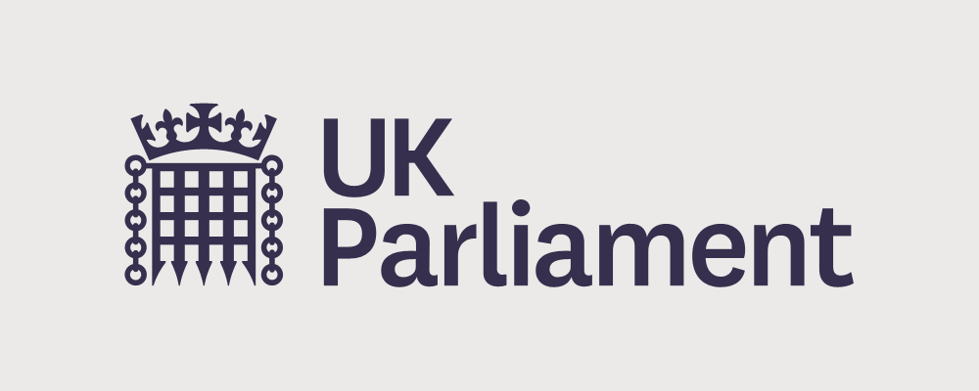 | Dear [put your MP’s name here: You can find this here https://members.parliament.uk/members/commons)  We are writing to you as you are our MP
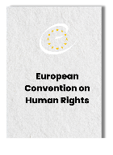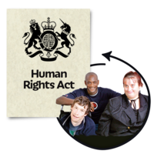 | We are asking you to help us protect our Human Rights Act and the European Convention on Human Rights.
 | Our Human Rights Act is very important to us. It protects us every day.
 | It makes sure we are treated with dignity and respect.
 | And it makes sure we are not discriminated against.  At the end of this letter there are some examples.
 | Human Rights are for us all. They are more important now than ever
 | With people worried about rising costs and not being treated equally. People with disabilities are already at a higher risk of fuel and food poverty.
 | We hope that you will support us. So we are asking you to:
 | - Speak up for the European Convention on Human Rights.
 | - Ask the UK Government to confirm that it will not change our Human Rights Act at a time when we need it most.
 | - Commit to voting against any piece of legislation which reduces rights.
 | Will you help us stand up for our human rights?
 | Thank you
Put your logo here if you have one | Put your name and organisation here, with an address or email

3 examples of why the Human Rights Act is important

- Yolande and her children faced destitution after fleeing domestic violence, but our Human Rights Act ensured they were housed by social services.

- A man with learning disabilities was given accommodation in which he had no access to a shower and his toilet and bed were in the same room, with no kitchen. A health professional used our Human Rights Act to ensure he was given suitable accommodation.

- Mark Woolcock, an NHS worker who died of COVID was entitled to a proper investigation into whether or not proper steps were taken by his employer to protect him.

